**ICP-OES (Inductively Coupled Plasma-Optical Emission Spectrometer)**

***ICP-OES PlasmaQuant 9000 Elite, Analytik Jena, Germany***

https://www.analytik-jena.com/products/chemical-analysis/elemental-analysis/icp-oes/

**Background**

ICP-OES (Inductively Coupled Plasma-Optical Emission Spectroscopy) is a powerful analytical technique utilized in laboratories for elemental analysis.

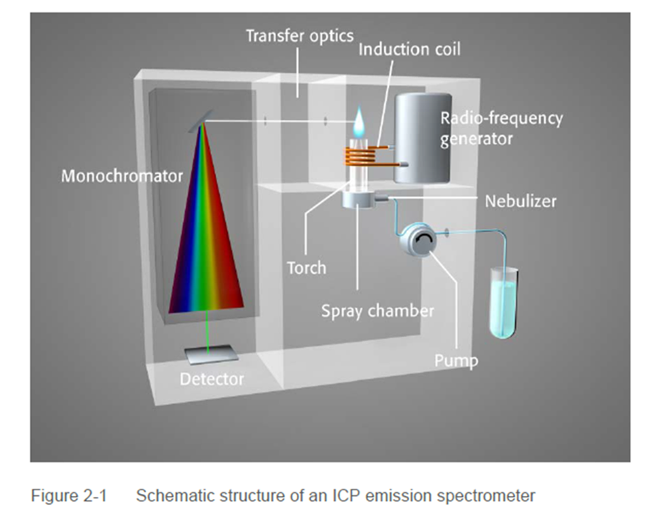

*Fig.1. Schematic structure of the sequential ICP-OES instrument (Analytik Jena, Germany)*

ICP-OES involves the use of an inductively coupled plasma, a high-temperature ionized gas, to atomize and excite the elements present in a sample. This plasma is generated by introducing a gaseous sample into a radiofrequency (RF) coil, which induces a high-frequency electromagnetic field. The energy from the RF field ionizes the gas, creating a plasma characterized by its intense heat and highly reactive environment.

*Fig. 2. ICP-OES plasma with a sea water sample inside. The emission of sodium (Na) in the visible part of the spectrum (orange light) is clearly visible (picture by Dr. Rosen).*

During the analysis, a small portion of the sample is introduced into the plasma, typically through a nebulizer. The high temperature of the plasma causes the sample to undergo atomization and excitation. Excited atoms within the plasma emit light at characteristic wavelengths that correspond to specific elements. This emitted light is then passed through an optical system, which disperses the light into its constituent wavelengths. A detector measures the intensity of the emitted light at these specific wavelengths, providing quantitative information about the elemental composition of the sample.

ICP-OES offers numerous advantages for elemental analysis. Firstly, it enables the simultaneous determination of multiple elements in a single analysis, covering a wide range of elements across the periodic table. This capability makes ICP-OES highly efficient and time-saving compared to other techniques. Additionally, it offers exceptional detection limits, allowing for the analysis of trace and ultra-trace elements in complex samples. The technique also exhibits excellent precision and accuracy, ensuring reliable results.

|  |  |
| --- | --- |
|  |  |

*Fig.3. The nebulizer (on the left) is responsible for aspirating the sample solution, while the spray chamber (on the right) works in conjunction with it. Together, they facilitate the delivery of sample droplets to the high-temperature argon plasma. (picture by Agilent).*

Please refer to the table below for the approximate Limit of Quantification (LOQ) values of the ICP-OES instrument utilized in our laboratory. It is important to note that these LOQ values are determined using a blank solution with a 1% HNO3 concentration, which represents a light matrix.

*

However, it's crucial to consider that the unknown sample may contain a higher acid concentration or different acids apart from HNO3. Additionally, there may be other elements present in the sample that are not among our analytes but are major components of the sample. As a result, the LOQ for the actual sample is typically higher, meaning it may yield less favorable results.

Please take this into account when interpreting the LOQ values for your specific samples. Our team of experts is available to provide further guidance and support in understanding and addressing the analytical challenges associated with your samples.

The applications of ICP-OES span various fields, including environmental monitoring, pharmaceutical analysis, food safety, geological studies, and material characterization. In environmental analysis, it enables the assessment of heavy metal contamination in soils and water samples. In pharmaceutical analysis, it ensures the quality control of drug formulations by quantifying elemental impurities. In the food industry, it helps ensure compliance with regulatory standards by determining the elemental composition of food products.

**Notes for our clients**

At our ICP Laboratory, we utilize ICP-OES for the analysis of liquid samples, particularly those that are acidic. If your samples do not fall into the category of drinking or distilled water, they need to undergo digestion in our specialized sample preparation laboratory.

When sending samples to our ICP Laboratory, it is important to complete the **submission form** and attach it to the parcel. This step is crucial to ensure proper handling and analysis of your samples. Please note that anonymous samples without a corresponding submission form will not be processed, even if you have recently contacted us by phone or email

The **submission form** allows us to gather essential information about your samples, such as sample type, origin, desired analyses, and any specific requirements. By providing this information, you help us streamline the process and ensure accurate and efficient analysis.

If you have any questions or need assistance with filling out **the submission form**, please feel free to contact us (vasiliyr@savion.huji.ac.il). We appreciate your cooperation in this matter and look forward to serving your analytical needs.

If you prefer to perform the acid digestion process on your own, please keep the following guidelines in mind:

Ensure that your samples are free from solid particles. Preferably, use a 0.45 µm filtration method.

* The minimum prepared sample volume required is 10 mL.
* Avoid using HF acid for sample preparation.
* Always prepare blank solutions (multiple blanks are preferable) to assess the purity of your reagents and digestion vessels.

These precautions help ensure accurate and reliable results during the analysis process.

Please note that the **submission form** is mandatory for all samples, including prepared samples that are sent to our laboratory.

Please refer to the **"FAQ"** page for detailed information on the sample submission process.

Should you have any further inquiries or require additional information, please do not hesitate to contact us via vasiliyr@savion.huji.ac.il.